

SGA Govt. Degree College, Yellamanchili

Department of Botany
Add on Course- 2025-26

TOPIC: IMPORTANT MEDICINAL PLANTS USED IN OUR DAILY LIFE
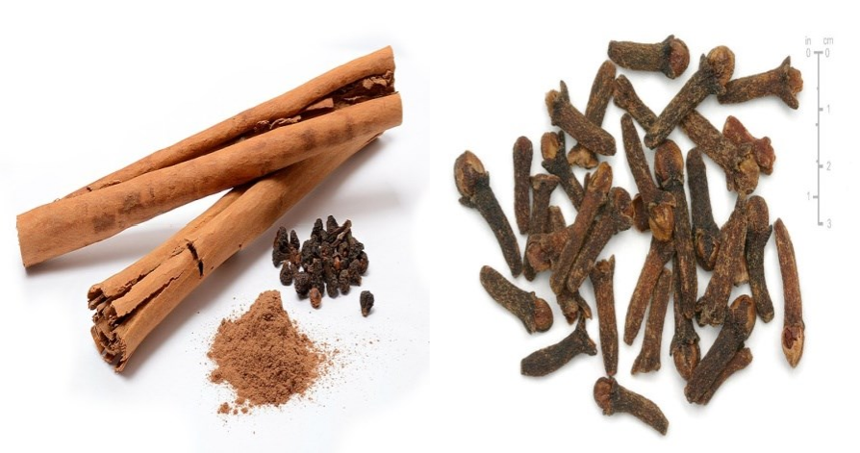
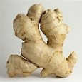

PERMISSION LETTER TO START ADD-ON COURSE

FROM TO
THE HEAD OF THE DEPARTMENT, PRINCIPAL,
DEPARTMENT OF BOTANY SGA GOVT. DEGREE COLLEGE,
SGA GOVT. DEGREE COLLEGE YELLAMANCHILI. YELLAMANCHILI.

Sir,
SUB: Permission to start an add-on course for 2025-26 and permission to
nominate the Botany faculty to teach classes for the add on course - regarding REF: Resolution copy of the department of Botany Dated 21-08-2025

As per the resolution of the department of Botany, we are very much glad to start an Add on course with a title “Important medicinal plants used in our daily life” for the B.Sc (Botany Hons) students. Hence, we are requesting you to give permission to start the Add on course and also permission to teach theory and practical classes for the said add on course.

Thanking you sir.




DEPARTMENT OF BOTANY DEPARTMENTAL MEETING

Minutes of the meeting Dated 21-08-202
The faculty of Botany department met in the Botany laboratory on 21-08-2025 and discussed the following matters

- It is resolved to start Add on course in the Department of Botany in the academic year 2025-26.
- To submit a letter to the principal for getting the permission to start an Add on course.
- To prepare syllabus to the Add on course
- To start the course with a minimum of 20 number of students.
- To conduct classes for add on course 15+15 teaching theory and practical hours respectively.
- Permission to utilize the Botany laboratory to conduct the practicals for this Add on course.
- Permission to conduct Add on course classes by the Botany faculty.

- Continuing the Add-on course for the next three years.

Department of Botany Add on Course for 2025-26
IMPORTANT MEDICINAL PLANTS USED IN OUR DAILY LIFE
Introduction
The Ayurvedic system of medicine is an age-old system of therapy, which is associated with the Vedic civilization in India. The oldest existing literature on this form of treatment is mentioned in Rigveda around 4500-1600 B.C. Ayurveda is a holistic system of treatment, which is amalgamation of use of food, medicine and other measures like exercise and behaviour. Life in Ayurveda is conceived as the union of body, senses, mind and soul. Ayurveda regards human body is a composition of five basic elements namely, earth, water, fire, air and vacuum. Any illness is considered the result of absence of a balanced state of the total body matrix. The disease is diagnosed by examining the general physical condition of the patient and pulse reading, along with examining urine, excreta, eyes, tongue, skin, and auditory functions. Once disease is diagnosed, the treatment measures involve use of medicines, specific diet and prescribed routine activity.
Wide arrays of plant species are used in traditional system of health care in India. Over 6,500 species of plants are known to occur in India those are used by various streams of traditional health care practitioners. Approximately 2000 medicinal plant species are used alone in Ayurvedic system of medicine, which is followed by Siddha (1121), Unani (751), Homeopathy (482) and Tibetan (337). The number of people involved in the traditional health care system is quite impressive in India. About 7,00,000 practitioners of Ayurveda, Siddha, Unani, Yoga, Naturopathy and Homeopathy are registered in the Indian Systems of Medicine.
Family traditions and cultural preferences also make people to own, decide and prefer various health care systems. In India, medicinal plants have strong acceptance in religious activities, where the plants are worshiped in the form of various gods, goddesses and local deities.
Plants are used as medicine by thousands of ethnic communities for human and veterinary health care, across the India. People across the world also rely upon the traditional systems of medicines, largely plant based, to meet their primary health care needs. Although modern medicine may be available in these countries, herbal medicines (phytomedicines) have often maintained popularity for historical and cultural reasons.
Assurance of the safety, quality, and efficacy of medicinal plants and herbal products has now become a key issue in industrialized and in developing countries. Both the general consumer and health-care professionals need up to date, authoritative information on the safety and efficacy of medicinal plants.
Somany important medicinal plants are regularly used in our daily life. In India, the people are using medicinal plants or their ingredients in the form of diet itself. Hence in India, the kitchen itself is a Medical store to cure all kinds of illness. Here are some important medicinal plants were taken which are used in our daily life.

Aims & Objectives:
- Promotion of cultivation and conservation of medicinal plants.
- To develop cultivation techniques for different climatic regions.
- To identify the important medicinal plants used in daily life.
- To use medicinal plants effectively for their diseases.
- To know the type of secondary metabolites present in the medicinal plant.

Course outcomes:
- The student will identify the medicinal plants.
- The student will know that, the medicinal plants can be used to cure diseases.
- The student will take steps to cultivate and conserve the medicinal plants.
- Familiarized with type of plant with type of secondary metabolite.
- Learn that the secondary metabolites are important to cure diseases.

SGA Govt. Degree College, Yellamanchili Department of Botany
Add on Course 2025-26
ENROLLED STUDENTS FOR THE ADD-ON COURSE

Name of the Course: Important medicinal plants used in our Daily Life

SL.NO | NAME | YEAR | GROUP | REGISTER  NUMBER
1. | ANITHA NANEPALLI | I Year | B.Sc Botany | 202503001
2 | DASARI GIRIJA LAXMI | I Year | B.Sc Botany | 202503003
3 | DHAVALA BHAVANI | I Year | B.Sc Botany | 202503004
4 | GARA SONI | I Year | B.Sc Botany | 202503005
5 | GURRAM SARANYA | I Year | B.Sc Botany | 202503007
6 | JAJALA MOUNIKA | I Year | B.Sc Botany | 202503008
7 | JOGA BHARATHI | I Year | B.Sc Botany | 202503009
8 | KALEM UMA | I Year | B.Sc Botany | 202503010
9 | KANDIPALLI HEMAMALINI | I Year | B.Sc Botany | 202503011
10 | KARANAM BHARGAVI | I Year | B.Sc Botany | 202503012
11 | KARANAM SWATHI APARNA | I Year | B.Sc Botany | 202503013
12 | KARRI SANDHYA | I Year | B.Sc Botany | 202503014
13 | KUDIRILLI MADHURI | I Year | B.Sc Botany | 202503015
14 | MARISA DURGA | I Year | B.Sc Botany | 202503016
15 | MARISA VEERA JYOTHI | I Year | B.Sc Botany | 202503017
16 | MARISETTI SREELATHA | I Year | B.Sc Botany | 202503018
17 | NAGA CHANDRA MANI UPPULURI | I Year | B.Sc Botany | 202503019
18 | NOWDU SAI DURGA | I Year | B.Sc Botany | 202503020
19 | PILLA GNANESWARI | I Year | B.Sc Botany | 202503021
20 | PITLA YAMUNA | I Year | B.Sc Botany | 202503022
21 | RAYAVARAPU KUSUMA | I Year | B.Sc Botany | 202503023
22 | SANAPATHI CHARMILA | I Year | B.Sc Botany | 202503024
23 | SOMIREDDY KRISHNAVENI | I Year | B.Sc Botany | 202503025
24 | TETAKALI LASYASRI | I Year | B.Sc Botany | 202503026
25 | VASUPALLI RAVI KIRAN | I Year | B.Sc Botany | 202503027
26 | VEGI BHAVANI | I Year | B.Sc Botany | 202503028
27 | YEDLA TUASI | I Year | B.Sc Botany | 202503029
28 | YELLAMANCHILI SIVA BHARATHI | I Year | B.Sc Botany | 202503030
29 | YERRAVARAVU DIVYA DURGA | I Year | B.Sc Botany | 202503031
30 | ANITHA NANEPALLI | I Year | B.Sc Botany | 202503001
31 | DASARI GIRIJA LAXMI | I Year | B.Sc Botany | 202503003
32 | DHAVALA BHAVANI | I Year | B.Sc Botany | 202503004
33 | ANAKAPALLI HEMADURGA | II Year | B.Sc Botany | 202403231
34 | ANUKU MANASA | II Year | B.Sc Botany | 202403232
35 | BALLANKI SHIVAGOWRI | II Year | B.Sc Botany | 202403234
36 | BONDHI JAGAMANI | II Year | B.Sc Botany | 202403235
37 | BOTTA SHIRISHA | II Year | B.Sc Botany | 202403236
38 | GANAGALLA KEERTHANA | II Year | B.Sc Botany | 202403243
39 | GANJI NAGADURGA | II Year | B.Sc Botany | 202403244
40 | KALAGA SNEHA | II Year | B.Sc Botany | 202403246
41 | MAMIDI SRAVANTH | II Year | B.Sc Botany | 202403248
42 | NAGIREDDI JAYASRI | II Year | B.Sc Botany | 202403249
43 | NALLAMATI NITHIN | II Year | B.Sc Botany | 202403250
44 | AKKUTHI MOUNIKA | II Year | B.Sc Botany | 202403253
45 | SANAPATHI DEVI | II Year | B.Sc Botany | 202403270
46 | SHIVAKOTI VALLIKA | II Year | B.Sc Botany | 202403260
47 | CHITIKELA ANITHA | II Year | B.Sc Botany | 202403238
48 | KASIMIKOTA LAVANYA | II Year | B.Sc Botany | 202403247
49 | BUDDA ASWINI | II Year | B.Sc Botany | 202403237
50 | PADMA SRI KILLADI | II Year | B.Sc Botany | 202403252
In-Charge of the Department Principal

Department of Botany Syllabus for
Add on Course, 2025-26
Topic: Important medicinal plants used in our daily life

Unit:1 15 Marks

- Morphology, phytochemistry and medicinal importance of Allium cepa.
- Morphology, Phytochemistry and medicinal importance of Allium sativum
- Morphology, Phytochemistry and medicinal importance of Cinnamomum verum
- Morphology, Phytochemistry and medicinal importance of Curcuma longa
- Morphology, Phytochemistry and medicinal importance of Zingiber officinale.

Unit:2 15 Marks

- Morphology, Phytochemistry and medicinal importance of Syzygium aromaticum
- Morphology, Phytochemistry and medicinal importance of Elettaria cardamom
- Morphology, Phytochemistry and medicinal importance of Trigonella foenum-graecum
- Morphology, Phytochemistry and medicinal importance of Terminalia chebula
- Morphology, Phytochemistry and medicinal importance of Rauvolfia serpentina

Medicinal Plants used in our Daily life

Allium cepa L.
  - Scientific name: Allium cepa L.
Family: Liliaceae

Vernacular names
English: Onion
Telugu: Vulli or Erragaddalu

Morphology:
    - A perennial herb, strong smelling when crushed.
    - Bulbs vary in size and shape from cultivar to cultivar, often depressed-globose and up to 20 cm in diameter;
    - Outer tunics membranous.
    - Stem up to 100cm tall and 30 mm in diameter,
    - Tapering from inflated lower part. Leaves up to 40 cm in height and 20mm in diameter.
    - Spathe often 3-valved, persistent, shorter than the umbel. Umbel 4– 9cm in diameter,
    - Stamens exserted; filaments 4–5mm, the outer subulate, the
inner with an expanded base up to 2 mm wide and bearing short teeth on each side.
    - Ovary whitish. Capsule about 5mm.
  - Useful part: Fresh or dried bulbs

Organoleptic properties:
Odour: strong, characteristic alliaceous.
Taste: strong, crushing or cutting the bulb stimulates lachrymation.

Major chemical constituents:
    - Sulfur and non-sulfur containing chemical constituents have been isolated from Bulbs.
    - The sulfur compounds are the most characteristic secondary metabolites.
    - The organic sulfur compounds includes thiosulfinates, thiosulfonates, cepaenes, S-oxides, S,S dioxides, monosulfides, disulfides, trisulfides, and zwiebelanes occur only as degradation products of the naturally occurring cysteine sulfoxides. S-propyl-L-cysteine sulfoxide.

Medicinal uses:
    - Used for treating Dysentery.
    - Used as a diuretic.
    - Used to treat ulcers, wounds, scars, keloids and asthma.
    - Used as an adjuvant therapy for diabetes.
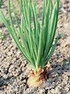
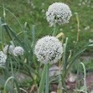
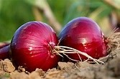
Onion Plant Flowering Onion Bulbs

Allium sativum L.
- Scientific name: Allium sativum L. Family: Liliaceae

Vernacular Names:
English: Garlic
Telugu: Vellulli or Thella gadda

Morphology:
  - A perennial, erect bulbous herb, 30–60 cm tall,
  - Strong smelling when crushed.
  - The underground portion consists of a compound bulb with numerous fibrous rootlets.
  - The bulb gives rise above ground to a number of narrow, keeled, grasslike leaves.
  - The leaf blade is linear, flat, solid, 1.0–2.5cm wide, 30–60 cm long, and has an acute apex. Leaf sheaths form a pseudostem.
  - Inflorescences are umbellate; scape smooth, round, solid, and coiled at first, subtended by membraneous, long-beaked spathe, splitting on one side and remaining attached to umbel. Small bulbils are produced in inflorescences.
  - Flowers are variable in number and sometimes absent, seldom open and may wither in bud. Flowers are on slender pedicels; consisting of perianth of 6 segments, about 4– 6mm long, pinkish.
  - Stamens 6, anthers exserted.
  - Ovary superior, 3-locular. Fruit is a small loculicidal capsule.
  - Seeds are seldom if ever produced
- Useful part: Fresh or dried Bulbs

Organoleptic properties:
Odour: strong, characteristic alliaceous Taste: very persistently pungent and acrid

Major chemical constituents:
  - The most important chemical constituents are the sulfur compounds.
  - The cysteine sulfoxides and the non-volatile γ-glutamylcysteine peptides make up more than 82% of the total sulfur content of garlic.
  - The compounds are thiosulfinates (Allicin ), ajoenes, Z-ajoene, vinyldithiins. And Sulphides, diallyl trisulfide.

Medicinal uses
  - Used as an adjuvant to dietetic management in the treatment of hyperlipidaemia.
  - Used in the prevention of atherosclerotic (age-dependent) vascular changes.
  - The drug may be useful in the treatment of mild hypertension.
  - Used for treatment of respiratory and urinary tract infections.
  - The herb has been used as a carminative in the treatment of dyspepsia.
  - Used as an aphrodisiac, antipyretic, diuretic, emmenagogue, expectorant, and sedative, to treat asthma and bronchitis, and to promote hair growth.
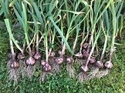
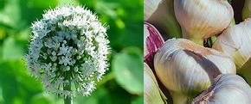

Garlic Plant Flowering Garlic Bulbs

Cinnamomum verum J.S. Presl.

- Scientific name: Cinnamomum verum J.S. Presl Family: Lauraceae

Vernacular names:
English: Cinnamon Telugu: Dalchini Chekka

Morphology:
  - A moderate-sized evergreen tree; bark rather thick, smooth, pale; twigs often compressed.
  - Young parts glabrous except the buds which are finely silky.
  - Leaves opposite or subopposite (rarely alternate), hard and coriaceous, 7.5–20 by 3.8–7.5 cm, ovate or ovate-lanceolate, subacute or shortly acuminate, glabrous and shining above, slightly paler beneath, base acute or rounded, reticulate venation.
  - Flowers numerous, in silky pubescent, lax panicles usually longer than the leaves; peduncles long, often clustered, glabrous or pubescent; pedicels long.
  - Perianth 5–6mm long; tube 2.5 mm long; segments pubescent on both sides, oblong or somewhat obovate, usually obtuse.
  - Fruit 1.3–1.7 cm long, oblong or ovoid-oblong, minutely apiculate, dry or slightly fleshy, dark purple, surrounded by the enlarged campanulate.
- Useful part: Bark

Organoleptic Properties:
Odour: characteristic and aromatic
Taste: characteristic, slightly sweet and fragrant.

Major chemical constituents
  - The major constituent is cinnamaldehyde, o-methoxycinnamaldehyde, eugenol and coumarin.

Medicinal uses:
  - Used for treatment of Dyspepsia.
  - Used for mild spastic conditions of the gastrointestinal tract and flatulence.
  - Used to increase appetite.
  - Used to treat abdominal pain with diarrhoea, and pain associated with amenorrhoea and dysmenorrhoea.
  - Also used in treatment of impotence, frigidity, dyspnoea, inflammation of the eye, leukorrhoea, vaginitis, rheumatism, neuralgia, wounds, and toothache.
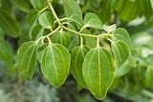
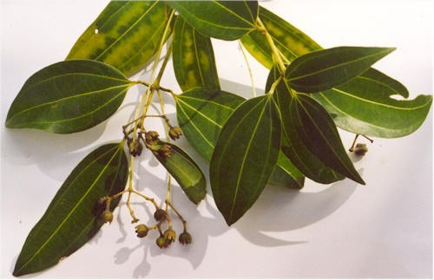
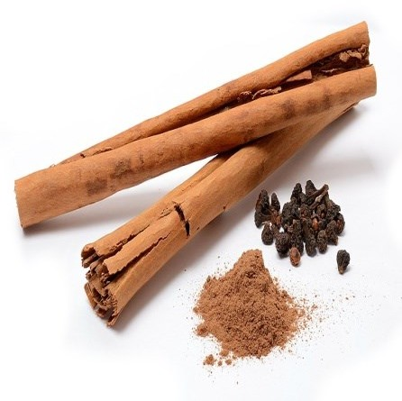
Cinnamon Plant Flowering Cinnamon Bark

Curcuma longa L.
- Scientific name: Curcuma longa L. Family: Zingiberaceae
- Vernacular names: English: Turmeric Telugu: Pasupu

Morphology:
  - Perennial herb up to 1.0 m in height; stout, fleshy.
  - Main rhizome nearly ovoid (about 3 cm in diameter and 4 cm long).
  - Lateral rhizome, slightly bent (2–6cm), flesh orange in colour.
  - Large leaves, lanceolate, uniformly green, up to 50cm long and 7–25cm wide, apex acute and caudate with tapering base.
  - Petiole and sheath sparsely to densely pubescent.
  - Spike, apical, cylindrical, 10-15cm long and 5–7 cm in diameter.
  - Bract white or white with light green upper half, 5–6 cm long, each subtending flowers, bracteoles up to 3.5 cm long.
  - Pale yellow flowers about 5cm long.
  - Calyx tubular, unilaterally split, unequally toothed.
  - Corolla white, tube funnel shaped, limb 3-lobed.
  - Stamens lateral, petaloid, widely elliptical, longer than the anther; filament united to anther about the middle of the pollen sac, spurred at base.
  - Ovary trilocular; style glabrous.
  - Capsule ellipsoid.
- Useful part: Dried rhizome

Organoleptic properties:
Odour: aromatic;
Taste: warmly aromatic and bitter, Drug when chewed colours the saliva yellow.

Major chemical constituents:
  - Pale yellow to orange-yellow volatile oil (6%) composed of a number of monoterpenes and sesquiterpenes, including zingiberene, curcumene, α- and turmerone among others.
  - The colouring principles (5%) are curcuminoids, 50–60% of which are a mixture of curcumin, monodesmethoxycurcumin and bisdesmethoxycurcumin.

Medicinal uses:
  - The principal use of Rhizome is for the treatment of acid, flatulence, Dyspepsia.
  - Used in treatment of peptic ulcers, and pain and inflammation due to rheumatoid arthritis and of amenorrhoea, dysmenorrhoea, diarrhoea, epilepsy, pain, and skin diseases.
  - Used in the treatment of asthma, boils, bruises, coughs, dizziness, epilepsy, haemorrhages, insect bites, jaundice, ringworm, urinary calculi, and slow lactation.
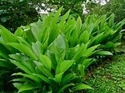
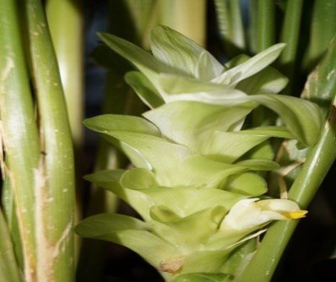
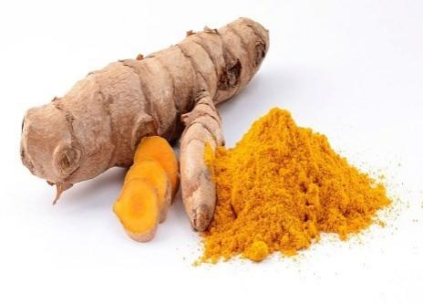

Turmeric Plant Flowering Turmeric Rhizome

Zingiber officinale Roscoe
- Scientific name: Zingiber officinale Roscoe Family: Zingiberaceae

Vernacular names:
English: Ginger
Telugu: Allam or Sonti

Morphology:
  - A perennial herb with a subterranean, digitately branched rhizome producing stems up to 1.50 m in height.
  - Leaves are linear lanceolate sheathing leaves (5–30cm long and 8–20 mm wide) that are alternate, smooth and pale green.
  - Flower stems shorter than leaf stems and bearing a few flowers.
  - Each flower surrounded by a thin bract and situated in axils of large, greenish yellow obtuse bracts, which are closely arranged at end of flower stem forming collectively an ovate-oblong spike.
  - Each flower shows a superior tubular calyx.
  - An orange yellow corolla composed of a tube divided above into 3 linear oblong, blunt lobes.
  - 6 staminodes in 2 rows, the outer row of 3 inserted at mouth of corolla, the posterior 2, small, horn-like and the anterior petaloid, purple and spotted and divided into 3 rounded lobes.
  - Ovary inferior with 3 carpels and ovary with tufted stigma.
  - Fruit a capsule with small arillate seeds.
- Useful part: Fleshy and dried rhizome

Organoleptic properties:
Odour: Characteristic aromatic. Taste: Pungent and aromatic.
Colour: Internally pale yellow to brown.

Major chemical constituents:
  - The rhizome contains 1–4% essential oil and an oleoresin.
  - The chief constituent sesquiterpene hydrocarbons (responsible for the aroma) seem to remain constant.
  - These compounds include Zingiberene, curcumene, sesquiphellandrene, and bisabolene. Monoterpene aldehydes and alcohols are also present. The constituents responsible for the pungent taste of the drug and possibly part of its anti-emetic properties have been identified as 1-(3-methoxy-4_-hydroxyphenyl)-5-hydroxyalkan- 3-ones, known as gingerols (having a side-chain with 7–10, 12, 14, or 16 carbon atoms, respectively) and their corresponding dehydration products, which are known as shogaols.

Medicinal uses:
  - Used as prophylaxis for Nausea and vomiting associated with motion sickness.
  - Used for postoperative nausea.
  - Used for pernicious vomiting in pregnancy and seasickness.
  - Used in treatment of dyspepsia, flatulence, colic, vomiting, diarrhoea, spasms, and other stomach complaints.
  - Powdered ginger is further employed in the treatment of colds and flu, to stimulate the appetite, as a narcotic antagonist and as an anti-inflammatory agent in the treatment of migraine headache and rheumatic and muscular disorders.
  - Used to treat cataracts, toothache, insomnia, baldness, and haemorrhoids, and to increase longevity.

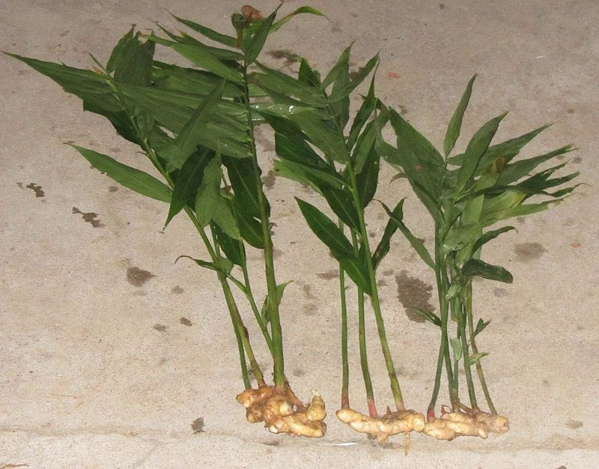
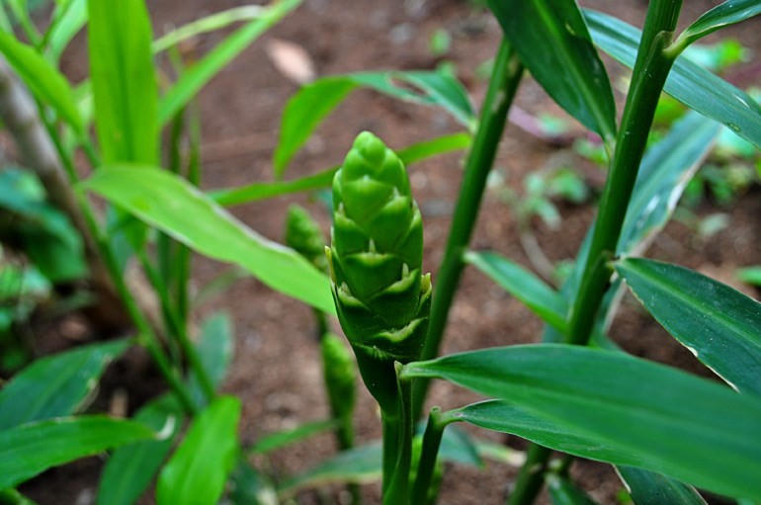
Ginger Plant

Flowering
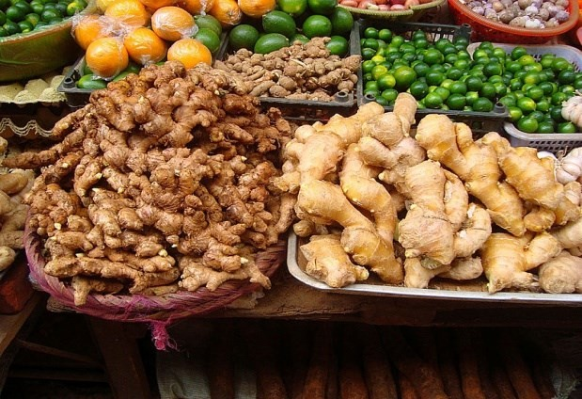
Ginger Rhizome Ginger in Market

Syzygium aromaticum (L.) Merrill et L.M. Perry
- Scientific name: Syzygium aromaticum (L.) Merrill et L.M. Perry Famiy: Myrtaceae

Vernaclar names:
English: Cloves Telugu: Lavangalu

Morphology:
  - Small evergreen trees, 10–20m high.
  - Leaves opposite, petiolate, lanceolate, pinkish to dark green, with translucent, aromatic glands, have a pungent odour when young.
  - Inflorescence occurs as racemose panicles and bears buds that take on the form of nails before blossoming.
  - Flowers red with 4 concave, overlapping petals that drop off as soon as the flower opens. Stamens numerous, 4 calyx lobes.
  - Fruit dark red, fleshy drupe.
  - Buds readily exude oil when pressed or scratched with a fingernail.
- Useful part: Dried flower buds.

Organoleptic properties:
Odour: characteristic, strongly aromatic. Taste: pungent, spicy.

Major chemical constituents:
  - The major constituent is an essential oil, which is characterized by the presence of eugenol (60–95%), eugenol acetate (2–27%), and a- and b-caryophyllene (5–10%).

Medicinal uses:
  - Used as External or local applications for the treatment of toothache and minor infections of the mouth and skin.
  - Also used as an antiseptic for dressing of minor wounds, and, in the form of lozenges, for sore throats and coughs associated with the common cold.
  - The essential oil (1–5%) is used in mouthwashes.
  - Used for treatment of asthma, bleeding gums, dyspepsia, fevers and morning sickness.
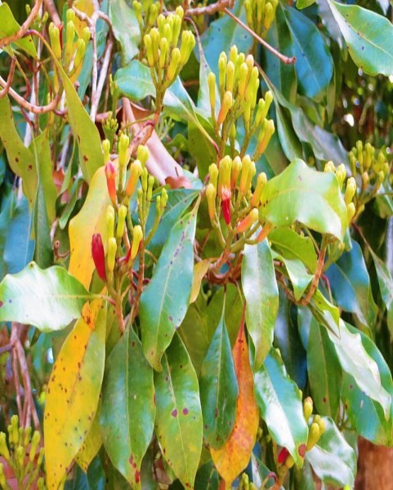
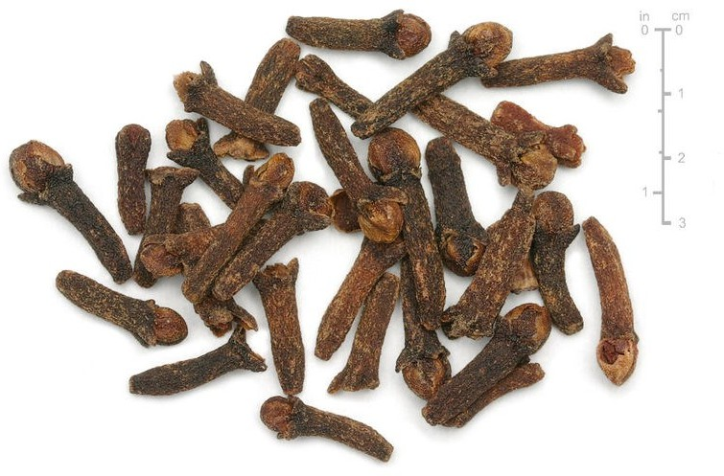

Clove Plant Cloves - Dried Flower Buds

Elettaria cardamomum (L.) Maton

- Scientific name: Elettaria cardamomum (L.) Maton Family: Zingiberaceae

Vernacular names:
English: Cardamon Telugu: Yalakulu

Morphology:
  - A perennial herb attaining a height of 2–4 m, with lanceolate leaves borne on long sheathing stems.
  - Flowers numerous, borne on horizontal racemes that arise from the rhizome and run horizontally along the ground.
  - The fruit is inferior, ovoid or oblong, nearly ellipsoidal, capsule plump or slightly shrunken.
  - The seeds of which are covered by an aril.
- Useful part: Dried Fruits.

Organoleptic properties:
Odour: aromatic.
Taste: Pungent and slightly bitter.

Major chemical constituents:
  - Contains 2–8% essential oil, the major constituents of which are 1, 8-cineole (20– 40%), terpinyl acetate (30–42%), terpineol (4–45%), limonene (6%), and smaller amounts of linalool and linalool acetate.

Medicinal uses:
  - Used for the treatment of Dyspepsia.
  - Treatment of asthma, bronchitis, colic, coughs, fainting, fever, rheumatism, stomach cramps and urinary stones.
  - Also used as an aphrodisiac, appetizer, diuretic and emmenagogue.

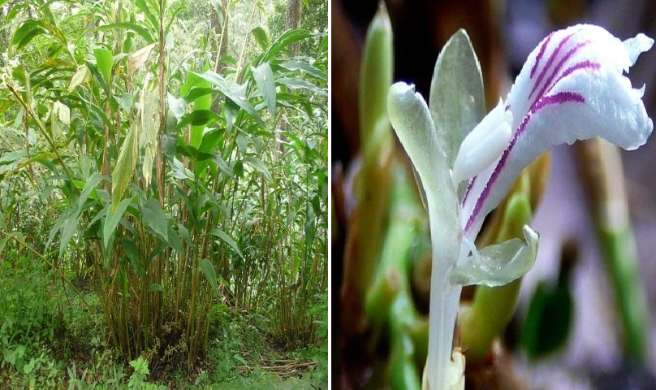
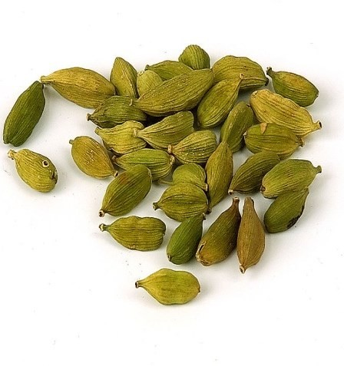

Cardamon Plant Flowering Cardamon Fruits

Trigonella foenum-graecum L.

- Scientific name: Trigonella foenum-graecum L. Family: Fabaceae

Vernacular names:
English: Fenugreek Telugu: Menthulu

Morphology:
  - Annual aromatic herb, up to 60 cm high with a well developed taproot and much branched roots.
  - Stem solitary or basally branched, terete, slightly pubescent, green to purple.
  - Leaves petiolate, alternate, trifoliolate; stipules triangular, small, adnate to the petiole. Rachis short. Leafl ets obovate or oblong, 1.5–4.0 cm long, 0.5–2.0 cm wide, upper part of margin denticulate.
  - Flowers whitish, solitary, axillary, subsessile, 12–15 mm long.
  - Calyx campanulate, finely pubescent, tube 4.5 mm long, with five lobes.
  - Pistil with sessile ovary, glabrous style and capitate stigma.
  - Fruits straight to occasionally sickle-shaped, linear pods, glabrous, with fine longitudinal veins, terminating in a beak 2–3 cm long.
  - Seeds oblong-rhomboidal, 3–5 mm long and 2–3 mm wide, with a deep furrow dividing each into two unequal lobes, with rounded corners, rather smooth, brownish.
- Useful part: Dried ripe seeds

Organoleptic properties:
Odour: characteristic, aromatic Taste: slightly bitter.

Major chemical constituents:
  - It is rich in mucilage (25–45%) and contains a small amount of essential oil (0.01%) and a variety of secondary metabolites, including protoalkaloids, trigonelline (up to 0.37%), choline (0.05%); saponins (0.6–1.7%) derived from diosgenin, yamogenin, tigogenin and other compounds.
  - Sterols including sitosterol, and flavonoids, among which are orientin, isoorientin and isovitexin.

Medicinal uses:
  - Used for the management of hypercholesterolaemia, and hyperglycaemia in cases of diabetes mellitus.
  - Prevention and treatment of mountain sickness.
  - Used Internally for loss of appetite, and externally as a poultice for local inflammations.
  - Treatment of pain, and weakness and oedema of the legs.
  - Used as an aphrodisiac, carminative, diuretic, emmenagogue, emollient, galactagogue and tonic.
  - Used in treatment of abdominal colic, bronchitis, diarrhoea, eczema, gout, indigestion, dropsy, fever, impotence, chronic cough, liver disorders, wounds and the common cold.
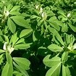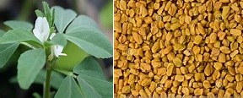

Fenugreek Plant Flowering Fenugreek seeds

Terminalia chebula Retz.
- Scientific name: Terminalia chebula Retz. Family: Combretaceae

Vernacular names:
English: Myrobalan Telugu: Karakkaya

Morphology:
  - A tropical shade tree, usually 15–20 m high, but can be up to 30 m in height, and up to 1.3 m in girth.
  - Bark rough, scaly, shoots and young leaves usually rusty villous.
  - Leaves simple, opposite, coriaceous, broadly ovate to ovate elliptic, 7–15 cm in width by 8–25 cm in length, glabrescent, veins obscure above, slightly raised and usually brownish pubescent beneath, apex acute or abruptly acuminate, base cuneate, slightly cordate or rounded.
  - Petiole 1–3 cm long, glabrous or sparsely pubescent with a pair of nodular glands near leaf base.
  - Inflorescences axillary or terminal panicles, usually with 3–6 spikes (each 3–6 cm long), rachis pubescent.
  - Flowers 2 mm long, 3–4 mm in diameter; bracts nearly glabrous, 1.5–2.0 mm long.
  - Calyx outside glabrous, inside densely villous, calyx segments triangular.
  - Stamens 3–4 mm long.
  - Ovary glabrous, ovoid, 1 mm long.
  - Style glabrous, 2.5–3.0 mm long, disc lobed, densely villous.
  - Fruit a drupe, glabrous, subglobose to ellipsoid, 2.5–5.0 cm by 1.5–2.5 cm, usually smooth or frequently 5-angulate, ridged, wrinkled, turning blackish when dry.
  - Seed is one, rough, ellipsoid, 1.0–2.0 cm by 0.2–0.7 cm, and without ridges.
- Useful part: Dried fruits

Organoleptic properties:
Odour: slight and characteristic.
Taste: bitter, sour, astringent, then sweet.

Major chemical constituents:
  - Major constituents of the fruit are hydrolysable tannins and components thereof, including chebulagic acid, chebulinic acid, chebulanin, corilagin, gallic acid, gallic acid methyl ester, punicalagin, terchebulin and terminalic acid.
  - Flavonols of interest include quercetin, isoquercitrin and rutin.

Medicinal uses:
  - Used orally to treat cough with sore throat, as well as diarrhoea.
  - Used orally as an anthelminthic, astringent, cardiotonic, dentifrice, diuretic and laxative.
  - Also used to treat bleeding gums, diabetes, gastrointestinal disorders, ulcers and urinary disorders.
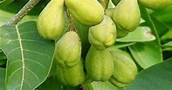
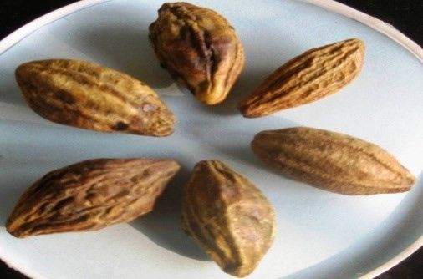

Myrobalan Plant Myrobalan Fruits

Rauvolfia sepentina (L.) Benth.ex Kurz
- Scientific name: Rauvolfia sepentina (L.) Benth.ex Kurz Family: Apocynaceae

Vernacular names:
English: Snake root Telugu: Sarpa Gandhi 3.Morphology:
  - Small, erect, glabrous shrub, 30–60 cm high.
  - Leaves whorled, 7.5–17.5 cm long, lanceolate or oblanceolate, acute or acuminate, tapering gradually into the petiole, thin.
  - Flowers white or pinkish.
  - Peduncles 5.0–7.5 cm long; pedicels and calyx red.
  - Calyx lobes 2.5 mm long, lanceolate.
  - Corolla about 1–1.3cm long, tube slender; inflated slightly above middle; lobes much shorter than tube, obtuse.
  - Drupes about 6 mm (diameter), single or didynamous and more or less connate, purplish black when ripe.
- Useful part: Root

Organoleptic properties:
Odour: Root is indistinct, earthy, reminiscent of stored white potatoes. Taste: Bitter.

Major chemical constituents:
  - It contains more than 60 indole alkaloids.
  - The principal hypotensive alkaloids are identified as reserpine and rescinnamine.

Medicinal uses:
  - The principal use is in the treatment of hypertension.
  - Used as a tranquillizer for nervous and mental disorders.
  - Used as a tonic in condition of asthenia.
  - Used as a cardiotonic and antipyretic, against snake and insect bites.
  - Used for constipation, liver diseases, flatulence, insomnia, and rheumatism.

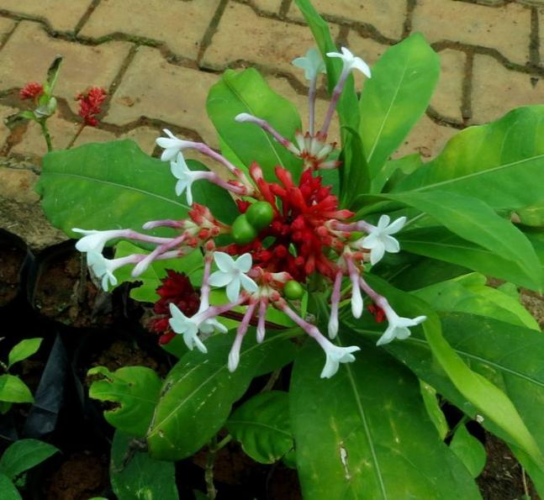
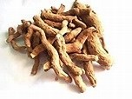
Snake Root Plant with Flowering Rauvolfia Roots

SGA Govt. Degree College, Yellamanchili Department of Botany

Model Question Paper Add on Course in Botany
Max.Marks.30 Time.11/2 hrs

- Answer all the questions. Each question carries 2 marks. 5X2=10 Marks
  - Medicinal uses of Ginger?
  - Medicinal uses of Rauvolfia?
  - Chemicals present in Cloves?
  - Chemicals present in Cardamon
  - Morphology of Curcuma longa
- Answer any 2 of the following questions. 2X5=10 Marks
- Explain the morphology and medicinal values of Garlic?
- Describe the morphology and medicinal values of Fenugreek?
- Describe the morphology and phytochemistry of Onion?
- Answer any one of the questions given. 1X10=10 Marks
- Explain the morphology, phytochemistry and medicinal values of Terminalia chebula?
- Explain the morphology, phytochemistry and medicinal values of Cinnamomum verum?

Department of Botany Add on Course 2025-26
Attendance of Enrolled students for Add on course
Name of the Course: Important medicinal plants used in our Daily Life

S.N O | NAME | GROUP | REGISTER NUMBER | Attendance
 | Dates |  |  | 04/  09 | 06/  09 | 09/  09 | 11/  09 | 13/  09 | 17/  09 | 18/  09 | 20/  09 | 23/  09 | 25/  09 | 27/  09 | 30/  09 | 03/  10 | 04/  10 | 07/  10
1. |  | I Year |  | P | P | P | P | P | P | P | P | P | P | P | P | P | P | P
2 |  | I Year |  | P | P | P | P | P | P | P | P | P | P | P | P | P | P | P
3 |  | I Year |  | P | P | P | P | P | P | P | P | P | P | P | P | P | P | P
4 |  | I Year |  | P | P | P | P | P | P | P | P | P | P | P | P | P | P | P
5 |  | I Year |  | P | P | P | P | P | P | P | P | P | P | P | P | P | P | P
6 |  | I Year |  | P | P | P | P | P | P | P | P | P | P | P | P | P | P | P
7 |  | I Year |  | P | P | P | P | P | P | P | P | P | P | P | P | P | P | P
8 |  | I Year |  | P | P | P | P | P | P | P | P | P | P | P | P | P | P | P
9 |  | I Year |  | P | P | P | P | P | P | P | P | P | P | P | P | P | P | P
10 |  | I Year |  | P | P | P | P | P | P | P | P | P | P | P | P | P | P | P
11 |  | I Year |  | P | P | P | P | P | P | P | P | P | P | P | P | P | P | P
12 |  | I Year |  | P | P | P | P | P | P | P | P | P | P | P | P | P | P | P
13 |  | I Year |  | P | P | P | P | P | P | P | P | P | P | P | P | P | P | P
14 |  | I Year |  | P | P | P | P | P | P | P | P | P | P | P | P | P | P | P
15 |  | I Year |  | P | P | P | P | P | P | P | P | P | P | P | P | P | P | P
16 |  | I Year |  | P | P | P | P | P | P | P | P | P | P | P | P | P | P | P

17 |  | II Year |  | P | P | P | P | P | P | P | P | P | P | P | P | P | P | P
18 |  | II Year |  | P | P | P | P | P | P | P | P | P | P | P | P | P | P | P
19 |  | II Year |  | P | P | P | P | P | P | P | P | P | P | P | P | P | P | P
20 |  | II Year |  | P | P | P | P | P | P | P | P | P | P | P | P | P | P | P
21 |  | II Year |  | P | P | P | P | P | P | P | P | P | P | P | P | P | P | P
22 |  | II Year |  | P | P | P | P | P | P | P | P | P | P | P | P | P | P | P
23 |  | II Year |  | P | P | P | P | P | P | P | P | P | P | P | P | P | P | P
24 |  | II Year |  | P | P | P | P | P | P | P | P | P | P | P | P | P | P | P
25 |  | II Year |  | P | P | P | P | P | P | P | P | P | P | P | P | P | P | P
26 |  | II Year |  | P | P | P | P | P | P | P | P | P | P | P | P | P | P | P
27 |  | II Year |  | P | P | P | P | P | P | P | P | P | P | P | P | P | P | P
28 |  | II Year |  | P | P | P | P | P | P | P | P | P | P | P | P | P | P | P
29 |  | II Year |  | P | P | P | P | P | P | P | P | P | P | P | P | P | P | P
30 |  | II Year |  | P | P | P | P | P | P | P | P | P | P | P | P | P | P | P
31
32
33
34
35
36
37
38
39
40
41
42
43
45
46
47
48
49
50



In-Charge of the Department Principal

DEPARTMENT OF BOTANY
ADD-ON COURSE IN, 2023-24
“Important Medicinal Plants Used in Our Daily Life” Marks Award List

SL.NO | NAME | YEAR | GROUP | REGISTER  NUMBER | Marks | Grade
1. |  | III Year | B.Sc (CBZ) | 722135405092
2 |  | III Year | B.Sc (CBZ) | 722135405095
3 |  | III Year | B.Sc (CBZ) | 722135405099
4 |  | III Year | B.Sc (CBZ) | 722135405106
5 |  | III Year | B.Sc (CBZ) | 722135405112
6 |  | III Year | B.Sc (CBZ) | 722135405113
7 |  | III Year | B.Sc (CBZ) | 722135405114
8 |  | III Year | B.Sc (CBZ) | 722135405115
9 |  | III Year | B.Sc (CBZ) | 722135405117
10 |  | III Year | B.Sc (CBZ) | 722135405118
11 |  | III Year | B.Sc (CBZ) | 722135405119
12 |  | III Year | B.Sc (CBZ) | 722135405121
13 |  | III Year | B.Sc (CBZ) | 722135405125
14 |  | III Year | B.Sc (CBZ) | 722135405128
15 |  | III Year | B.Sc (CBZ) | 722135405130
16 |  | II Year | B.Sc Botany (Hons) | 723135405065
17 |  | II Year | B.Sc Botany (Hons) | 723135405067
18 |  | II Year | B.Sc Botany (Hons) | 723135405074
19 |  | II Year | B.Sc Botany (Hons) | 723135405075
20 |  | II Year | B.Sc Botany (Hons) | 723135405077
21 |  | II Year | B.Sc Botany (Hons) | 723135405088
22 |  | II Year | B.Sc Botany (Hons) | 723135405090
23 |  | II Year | B.Sc Botany (Hons) | 723135405091
24 |  | II Year | B.Sc Botany (Hons) | 723135405093
25 |  | II Year | B.Sc Botany (Hons) | 723135405096
26 |  | II Year | B.Sc Botany (Hons) | 723135405100
27 |  | II Year | B.Sc Botany (Hons) | 723135405103
28 |  | II Year | B.Sc Botany (Hons) | 723135405104
29 |  | II Year | B.Sc Botany (Hons) | 723135405115
30 |  | II Year | B.Sc Botany (Hons) | 723135405116
31
32
33
34
35
36
37
38
39
40
41
42
43
45
46
47
48
49
50

In-Charge of the Department Principal



DEPARTMENT OF BOTANY
ADD-ON COURSE 2025-26 IN

“Important Medicinal Plants Used in Our Daily Life”
CERTIFICATE
This is to certify that Mr./Ku S/o/D/o
Group Regd. No has successfully completed the Add-on course in “Important Medicinal Plants Used in our Daily Life” in this college held from to and awarded with Grade.

Head of the Department Principal

DEPARTMENT OF BOTANY
ADD-ON COURSE IN

“Important Medicinal Plants Used in Our Daily Life”
Summary Report
The Department of Botany has started Add-on Course on the topic entitled “Important Medicinal Plants Used in our Daily Life” with 30 Students from III CBZ Group. The faculty of Botany Department have conducted 15 theory and 15 practical classes to complete the syllabus within stipulated time. The Exams were conducted to registered students for 30 marks and issued certificates to 30 successful students.
The Knowledge of Ayurvedic information is hidden in the books only and not used by the people and became wasted. To make proper usage and to make an awareness on important medicinal plants present in the kitchen of every home, the Department of Botany has aimed to start this Add-on course. So that the people became aware of plants products present in the kitchen and can able to cure their routine ailments in their daily Life. We treat our kitchen itself as a herbal medical store in our home. By effective usage of these herbal products from kitchen makes everybody acquire good health and fulfils the principle of “All is Well”.
- Number of students enrolled: 30
- Number of students completed: 30
- Theory hours: 15
- Practical hours: 15
- Maximum Marks: 30
- Time: 1 1/2 hours


Course Co-ordinator Principal

